Vortex Shedding and Drag Effects on Instrument Mount

Lucas Simmonds | Charlie Nitschelm | Ross Thyne

May 6, 2019

Contents

Table of Figures 3

Table of Tables 3

Abstract 4

Introduction 4

Description of Methods 5

Results and Discussion 9

Summary and Conclusions 12

References 13

Appendix 14

Table of Data 14

MATLAB Code 14

With Fairings 14

Equipment 15

Miscellaneous 15

Facilities 16

Support 16

Project Schedule 17

# Table of Figures

Figure 1 - Strouhal Number vs Reynolds Number for a Circular Cylinder2 5

Figure 2 - Coefficient of Drag vs Reynolds Number for a Circular Cylinder 7

Figure 3 - Mounting design of the strut when it is attached to the Tow Tank 8

Figure 4 - Free body diagram of the strut during the test 8

Figure 5 - Load cell calibration curve at set weights of 0, 20 and 40 lbs of force 9

Figure 6 - Drag force experienced by the strut with and without fairings as measured by the load cell 10

Figure 7 - ADV data output with the fast Fourier transform for the constant velocity portion of the test 11

Figure 8 - Both FFT graphs for the strut with and without fairings that show the apparent natural frequency 12

# Table of Tables

Table 1 - Experimental Parameters 6

Table 2 - Predicted Values for Vortex Shedding Data 6

Table 3 - Predicted Drag Data 7

# Abstract

Vortex shedding is a natural phenomenon that can have negative effects on structural integrity, data collection and overall data quality. The Living Bridge Project has been exploring the wants and needs of installing a hydrokinetic turbine in the Piscataqua River current. A strut must withstand a current speed of approximately 2 m/s, which can have a large effect on the overall data collection quality that the researchers of the Living Bridge Project require. This problem has caused us to analyze what can be done to limit the overall effect of the vortex shedding on the strut.

To accurately and precisely understand the problem and propose a solution, an Acoustic Doppler Velocimeter (ADV) and load cell were used to get data on the vortex shedding frequency and magnitude and the overall drag force the strut experiences respectively to understand how these measurements connect.

A total of two tests were conducted within the UNH Tow Tank in Chase Hall at the University of New Hampshire with a carriage speed of 2 m/s to simulate the environment the strut will be in on the field. One test was to simulate the bare strut, as it is on the field right now. The second was with the addition of fairings and other connection pieces. This test is a proposed design for the field that could lower drag and the overall frequency and magnitude of the affected vortex shedding the strut creates on itself and the entire system.

A dominant natural frequency of 9.25 Hz was experienced by the bare strut during the first test with an overall drag force of 130 N. Once the fairings were attached and the test was run again, no dominant frequencies on the strut were detected, but the drag force increased to 210 N. It is expected that the induced vortex shedding is not a function of overall drag force, but of the overall geometry of the strut.

# Introduction

Is it possible to improve our understanding of data collected in the Piscataqua River with one simple fairing design? The design of this experiment will include quantitatively measuring the total drag force on different cross-sections of struts and their apparent natural frequency induced by vortex shedding.

The Living Bridge Project is currently exploring what it takes to implement a hydrokinetic turbine in the Piscataqua River. In order to do so, a velocity profile of the complex flow created by the bridge pier and turbine must be analyzed for optimal turbine efficiency. Vortex shedding and drag effects make deploying instruments and obtaining data difficult to do. Getting controlled laboratory data on the vortex shedding experienced on the strut with a certain force of drag will assist the team with the analysis of field data at the Memorial Bridge Tidal Turbine. This will be done by attaching the measurement device on a strut and attaching it to the tow carriage with a custom made mount, outfitted with a load cell to obtain drag force data. This will be done in Chase Hall at the University of New Hampshire.

The strut will be equipped initially with no fairings and towed across the tank to gain a base understanding of the vortex shedding and drag effects. It will then be outfitted with custom made fairings and towed back across the tank to analyze the effect the fairings have on the vortex shedding and drag force. The drag force will be experimentally determined for both the circular cylinder and the circular cylinder with fairings and compared with analytical models for the generic geometries being used. The equation below will be used to calculated predicted drag force,

$$F_{D}=\frac{1}{2}ρC_{D}AU^{2}$$

By recording the velocity at which the strut moves through the water, the Reynolds and Strouhal number can be calculated using the equations,

$Re=\frac{ρUD}{μ}$

$St=\frac{fD}{U}$

The Strouhal number is a dimensionless number that describes oscillating flow mechanisms. We will be comparing our experimental Strouhal numbers with tabulated values. Once the natural frequency induced by the vortex shedding has been identified, this information can be further used to understand velocity measurements taken in the field.

# Description of Methods

In order to understand our results, we must first make predictions as to what the behavior of our system will be. We started by first calculating the Reynolds number for the circular cylinder and the circular cylinder with fairings using the equation for Reynolds number. This formula can be used for both the circular cylinder and the circular cylinder with fairings because the fairings were designed as NACA 0020 airfoils with the same diameter as the circular cylinder. Using the figure below from the textbook, *Handbook of Experimental Fluid Mechanics*, which contains experimental data on the relationship between Reynolds Number and Strouhal number for a circular cylinder, we could find the Strouhal number for our experiment.

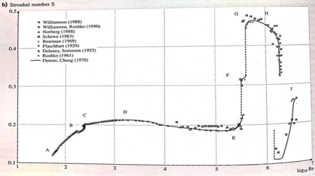

Figure 1 - Strouhal Number vs Reynolds Number for a Circular Cylinder2

Using the Strouhal number obtained from Figure 1, we can use the equation for the Strouhal number to solve for the dominant natural frequency that we expect to see in our fast Fourier transform. This value can be compared to the actual frequency we obtain through a fast Fourier transform of the experimental data. Although the circular cylinder with fairings will be subjected to the same Reynolds number as the circular cylinder, we are expecting no shedding frequency. Tables of the experimental parameters and predicted behaviors can be found below.

Table 1 - Experimental Parameters

|  |  |  |  |  |  |  |
| --- | --- | --- | --- | --- | --- | --- |
|  | **Diameter [m]** | **Chord [m]** | **Velocity [m/s]** | **Density [kg/m3]** | **Dynamic Viscosity [Pa s]** | **Kinematic Viscosity [m2/s]** |
| **Circular Cylinder** | 0.06 | N/A | 2 | 998.2 | 1.002*10-3 | 1.002*10-6 |
| **Circular Cylinder with Fairings** | 0.06 | 0.152 | 2 | 998.2 | 1.002*10-3 | 1.002*10-6 |

Table 2 - Predicted Values for Vortex Shedding Data

|  |  |  |  |  |
| --- | --- | --- | --- | --- |
|  | **Reynolds Number (Re)** | **Reynolds Number based off chord (Rec)** | **Strouhal Number (St)** | **Shedding Frequency (Hz)** |
| **Circular Cylinder** | 119,544 | N/A | 0.19 | 6.33 |
| **Circular Cylinder with Fairings** | 119,544 | 304,100 | 0 | 0 |

        The velocity data will be recorded using an Acoustic Doppler Velocimeter (ADV). This device utilizes the Doppler effect to convert frequency shifts to velocity of the flow. In order to use this device, the UNH Tow Tank was seeded with 11 micrometer diameter glass spheres.

To prepare the data, correlation and signal-to-noise values obtained from the Nortek ADV user manual were used to filter the data. The constant velocity portion of the data was considered. The average velocity of the constant velocity section was subtracted from the data to prepare it for a fast Fourier transform. Then a fast Fourier transform was performed on the constant velocity section and visually analyzed for shedding frequency.

In order to test the effectiveness of the fairings, we will measure and compare the drag force on the circular cylinder and circular cylinder with fairings. First, we used the calculated Reynolds numbers to estimate the coefficient of drag for a circular cylinder using the figure below from the textbook, *Handbook of Experimental Fluid Mechanics*, which contains data on coefficient of drag vs. Reynolds number for a circular cylinder.

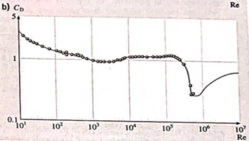

Figure 2 - Coefficient of Drag vs Reynolds Number for a Circular Cylinder

        Using the value for coefficient of drag obtained from our Reynolds number, we can estimate the drag force on the circular cylinder using the drag equation below,

$$F_{D}=\frac{1}{2}ρC_{D}AU^{2}$$

Where the density of the fluid, CD is obtained from Figure 2, *A* is the area of the cylinder exposed to the flow, and *U* is the velocity of the flow. For the circular cylinder with fairings the chord length of our airfoils must be used to determine the Reynolds number. This number can be found in Table 2. Using this Reynolds number, we checked tabulated values for the coefficient of drag of a NACA 0020 airfoil at a 0-degree angle of attack. The calculated values for the drag force can be found in the table below.

Table 3 - Predicted Drag Data

|  |  |  |
| --- | --- | --- |
|  | **Coefficient of Drag (CD)** | **Force of Drag (FD) [N]** |
| **Circular Cylinder** | 1.3 | 218 |
| **Circular Cylinder with Fairings** | 0.018 | 3 |

In order to record the drag force data, a mount for the tow carriage was designed that supported the transverse weight of the strut. A picture of the design mount can be seen in Figure 3 below.

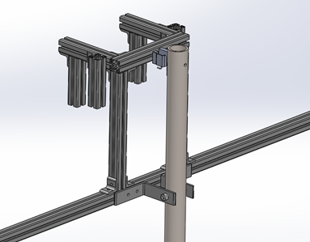

Figure 3 - Mounting design of the strut when it is attached to the Tow Tank

The strut is pinned to the mount as to allow the full force of the drag be transferred to the load cell. Due to the design of the mount, the force recorded was in the form of a moment. In order to find the drag force, the length of strut submerged was used to find the resultant force and the moments were summed about the pin. A diagram of the setup can be seen in Figure 4 below.

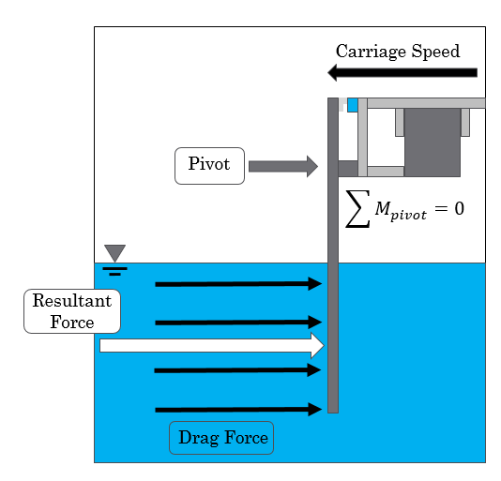

Figure 4 - Free body diagram of the strut during the test

# Results and Discussion

The load cell was calibrated using weighted plates. The weights of the plates were known and were stacked on top of the load cell while recording the voltage output at each increment. These data points were then plotted, and a linear fit was applied. This linear relationship was used as the conversion factor to convert load cell voltage to force-pounds. Figure 5 below illustrates the calibration curve that was produced from this.

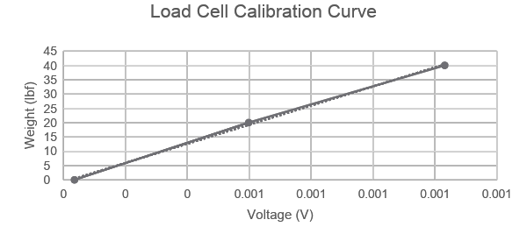

Figure 5 - Load cell calibration curve at set weights of 0, 20 and 40 lbs of force

The equation below was created when a line of best fit was produced to match the data that was read in from the load cell with known input weights. Once the output voltage of the load cell could be represented as a force, it then had to be manipulated to represent the actual drag force on the strut. By knowing the pin location, the load cell and the assumed location of the resultant force due to drag on the strut, the actual drag force could be easily calculated. The figure below shows the actual drag force with respect to the time of the test for the strut with and without fairings.

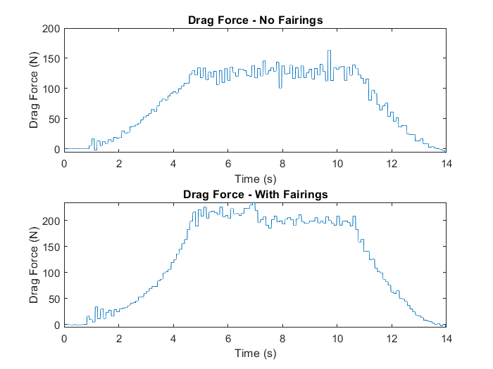

Figure 6 - Drag force experienced by the strut with and without fairings as measured by the load cell

From the figure above, it is clear that the total drag force increases when the fairings were attached. The average total drag force when the strut is moving through the water at 2 m/s was 130 N, while the drag on the strut with fairings was 210 N. This is because the fairings that were used to simulate a NACA 0020 airfoil were far from it. Their diameter was larger than the outside diameter of the strut. The fairing was also not solid, allowing water to pour inside of it, greatly increasing the drag it would encounter during the test. Now that drag of the two tests are understood, we must analyze the vortex shedding effects on both situations to understand if the vortex shedding increases or decreases with the addition of the fairings, and if it is a function of total drag on the strut or if it is function on the actual geometry.

Figure 7 below contains two interconnected graphs, the top one being the raw data output from the ADV, then an analysis of that data to obtain a fast Fourier transform (FFT) to show any natural frequencies that might have been obtained. The average velocity that was detected by the ADV was 2 m/s, exactly lining up with the setting we sent to the tow tank to move the carriage around. Figure 7 shows just the data for the strut with no fairings.

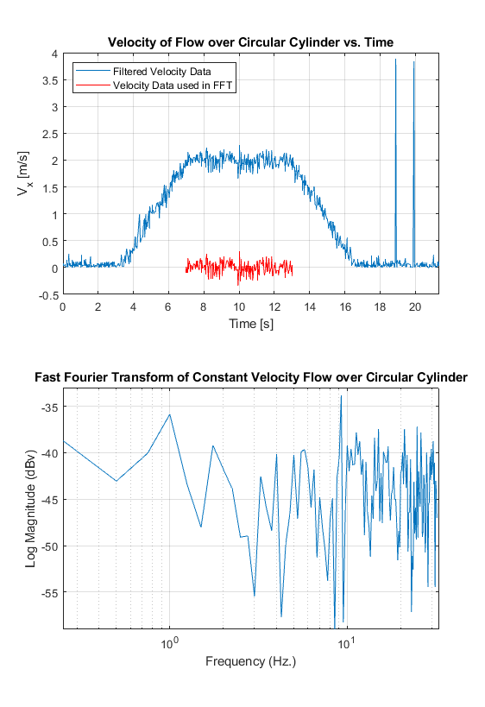

Figure - ADV data output with the fast Fourier transform for the constant velocity portion of the test

When both tests were completed, we needed to compare and contrast the two FFT’s that were calculated, and their apparent natural frequencies of the vortex shedding. Figure 8 below plots both tests out. An obvious peak appears for the strut without fairings at a vortex shedding natural frequency of 9.25 Hz. Looking at the bottom plot, there is no obvious peak providing the conclusion that the ADV did not pick up any natural frequencies, meaning the vortex shedding was much smaller.

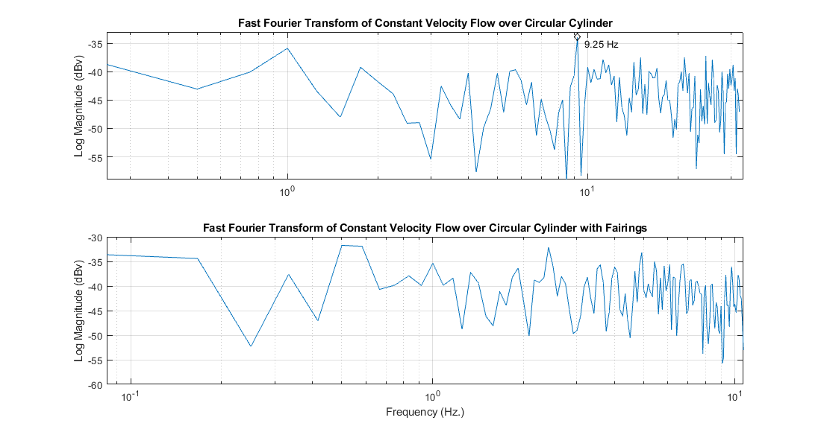

Figure - Both FFT graphs for the strut with and without fairings that show the apparent natural frequency

# Summary and Conclusions

This experiment was to assist in determining the solution to reduce the vortex shedding the strut encounters in the Piscataqua River as part of the Living Bridge Project. The two tests we conducted were having the strut that is in the field encounter a flow of two m/s with no fairings attached, and a proposed solution of plastic fairings attached.

Using the basic drag equation, an estimated amount of drag for the strut without fairings was 218 N, while an actual drag force of 150 N was seen. But, for the strut with fairings assuming a perfect NACA 0020 airfoil, 3 N was predicted but 210 N was experienced. This increase of 60 N from the actual strut without fairings is due to not having a perfect airfoil, and also allowing water to be trapped within the fairing, increasing drag tremendously. Once the drag data was calculated, a deeper look can go into the vortex shedding data to see if there is any connection.

From above, a natural frequency can be predicted using the Reynolds number and Strouhal number which in turn predicts the vortex shedding the strut could encounter in the field. 6.33 Hz was predicted for the strut without fairings, but a vortex shedding frequency of 9.25 Hz was calculated using the ADV data and implementing a FFT to the velocity data. This 46% difference is large, but fairly accurate considering the order of frequencies that the strut could experience. For the strut with fairings, no natural frequencies were picked up, meaning no apparent vortex shedding on the strut.

This experiment provided an insight with the connection between drag and vortex shedding, as well as the best way to reduce vortex shedding on the strut in the field. Although drag increased with the addition of fairings, the vortex shedding decreased, meaning that drag force does not have a direct influence on the vortex shedding, but the overall geometry does. For the final recommendation, an improved fairing design should be implemented to decrease drag, but still maintain a NACA 0020 foil geometry as this has proven to reduce vortex shedding.

# R**eferences**

[1] Tropea, Cameron, et al. *Springer Handbook of Experimental Fluid Mechanics*. Springer, 2016.

[2] Dynnikov, Yaroslav. “Karman Vortex Street Past a Cylinder.” YouTube, YouTube, 13 Oct. 2011, www.youtube.com/watch?v=3mULL6O6f38.

[3] Unh-Oe, Woznik. “UNH-OE/Wave-Tow-Tank.” *GitHub*, github.com/UNH-OE/wave-tow-tank/wiki.

# Appendix

## Table of Data

|  |  |
| --- | --- |
| **Voltage** | **Weight** |
| 3.55877E-05 | 0 |
| 0.000598376 | 20 |
| 0.00123164 | 40 |

## MATLAB Code

clear all

close all

% Reading in Excel Load Cell File

MomentVoltage = xlsread('LoadCell_NoFairings.xlsx','Data' ,'A2:A50008'); % Second

Moment = MomentVoltage.*33405-.7733;

D1 = 16; % Length of pin to load cell

D2 = 43; % Length of pin to concentrated drag force

Force = (Moment*D1)/D2 ;

Force_Cal = 0 - Force(1);

Force = Force + Force_Cal;

Force = Force/.225;

Time = linspace(0,length(Force)/100,length(Force))-2;

figure(1)

plot(Time,Force)

xlabel('Time (s)')

ylabel('Drag Force (N)')

title('Drag Force - No Fairings')

xlim([0,14])

## With Fairings

Reading in Excel Load Cell File

MomentVoltage2 = xlsread('LoadCell_Fairings.xlsx','Data' ,'A2:A50008'); % Second

Moment2 = MomentVoltage2.*33405-.7733;

D1 = 16; % Length of pin to load cell

D2 = 43; % Length of pin to concentrated drag force

Force2 = (Moment2*D1)/D2;

Force2_Cal = 0 - Force2(3);

Force2 = Force2 + Force2_Cal;

Force2 = Force2/.225

Time2 = linspace(0,length(Force2)/100,length(Force2))-5;

figure(2)

plot(Time2,Force2)

xlabel('Time (s)')

ylabel('Drag Force (N)')

title('Drag Force - With Fairings')

xlim([0,14])

figure(3)

subplot(2,1,1)

plot(Time,Force)

xlabel('Time (s)')

ylabel('Drag Force (N)')

title('Drag Force - No Fairings')

xlim([0,14])

subplot(2,1,2)

plot(Time2,Force2)

xlabel('Time (s)')

ylabel('Drag Force (N)')

title('Drag Force - With Fairings')

xlim([0,14])

## Equipment

### Miscellaneous

* 2 Load Cells
* ADV and mounting system
* 2.375” Pipe
* Pipe with connected Fairing
* Seeding
* 1 T-slotted Framing $27.30
* 6 Silver Corner Bracket $37.56 Total
* 2 Packs of 4 SS End-Feed Fasteners $9.02

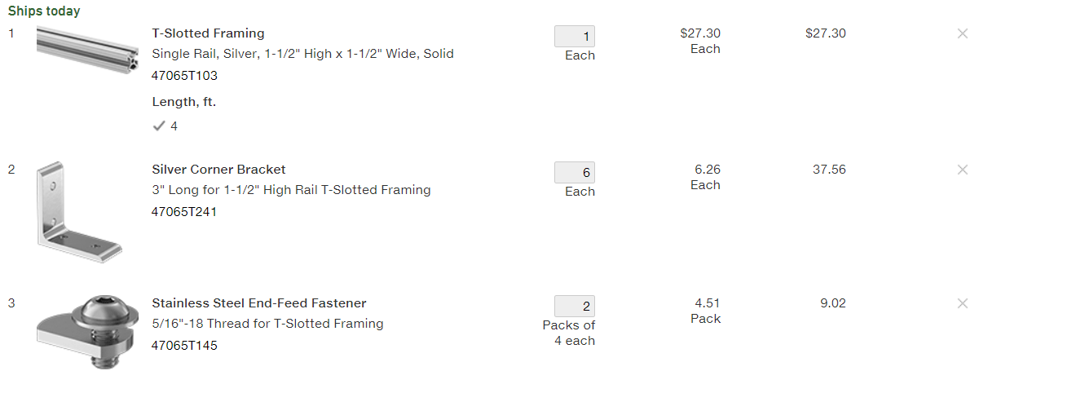

## Facilities

The test was performed at the Chase Ocean Engineering lab in the UNH Tow Tank. We will be using the track cart on the tow tank and attaching our system to it via a side mounting mechanism of our design. An integrated DAQ system will be utilized to record the data from the test, which is already a system integrated within the carriage.

## Support

Support was needed with regards to using the ADV as a system and understanding the data that is collected by the instrument. Kaelin is the assumed source of information in this situation in complement to our own personal research. Support will also be needed in the operational procedure of running the UNH Tow Tank and the connected data collection system, to ensure our experiment is run properly and the data is collected from the sources we need. The water must be seeded as it is passing through the ADV’s data recording area; however, we will most likely be able to do this ourselves with a little bit of guidance from people who are experienced with the Tow Tank.

## Project Schedule

